Part 2 - Exploratory Data Analysis (EDA) using Apache Spark
Project Title - Financial Forecasting Frontier: Distributed Machine Learning for Banking Analytics

Objective
The objective of this phase is to perform Exploratory Data Analysis (EDA) on the banking dataset using Apache Spark. Unlike traditional data analysis tools that process data on a single machine, Spark distributes the workload across multiple partitions, making it suitable for analyzing large-scale banking datasets efficiently.
The EDA process helps identify data quality issues, customer behavior patterns, feature distributions, and relationships that are useful for predictive modeling.

Why Apache Spark for EDA?
Banks generate millions of customer records every day. Processing such datasets using conventional libraries like Pandas becomes inefficient due to memory limitations.
Apache Spark provides:
- Distributed processing
- Parallel execution
- Fault tolerance
- Faster computation
- Scalability across multiple machines
Spark DataFrames allow large datasets to be analyzed without loading the complete data into a single machine's memory.

Dataset Overview
The analysis is performed on the Bank Marketing Dataset, which contains customer information collected during direct marketing campaigns.
Important features include:
- Age
- Job
- Marital Status
- Education
- Balance
- Housing Loan
- Personal Loan
- Contact Method
- Campaign Information
- Previous Campaign Outcome
- Subscription Status (Target Variable)
The target variable y indicates whether a customer subscribed to a term deposit.

Spark Environment Setup
The analysis begins by creating a Spark Session and loading the dataset into a Spark DataFrame.
Spark automatically partitions the data, enabling parallel computation across available processing cores.
This distributed execution improves performance and allows the workflow to scale for much larger datasets.
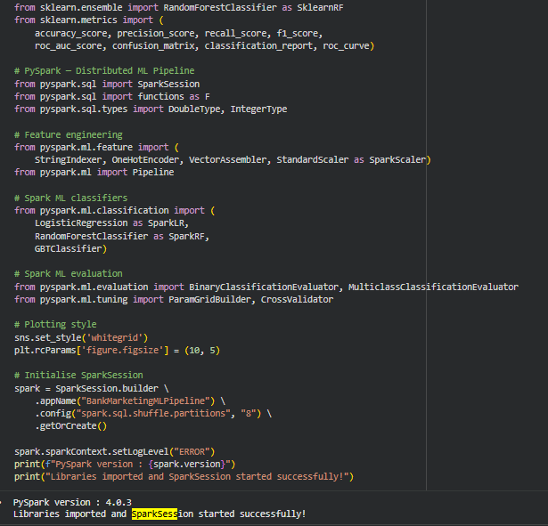
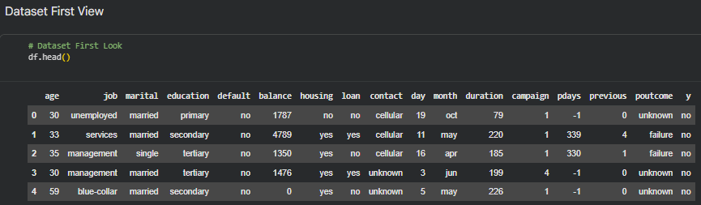

Data Inspection
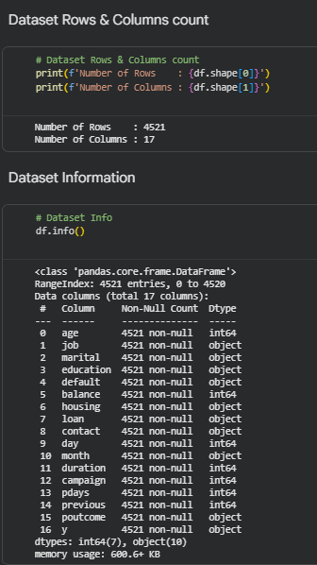
The initial inspection includes:
- Displaying the dataset schema
- Viewing sample records
- Checking data types
- Counting total records
- Counting total columns
These steps ensure that the dataset has been loaded correctly before performing further analysis.

Data Quality Assessment
A comprehensive data quality check is performed to identify missing or inconsistent values.
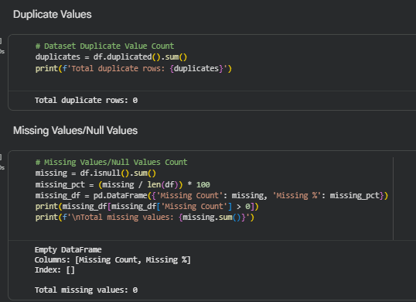
The following checks are carried out:
- Null value detection
- Missing record verification
- Duplicate inspection
- Data type validation
Ensuring high-quality data is essential before building predictive models.

Descriptive Statistics
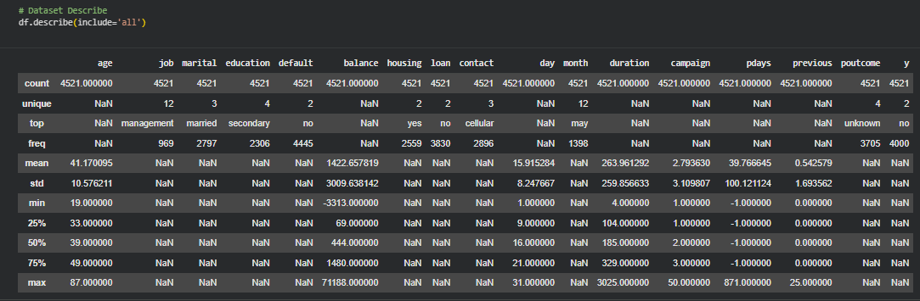
Spark's distributed aggregation functions are used to generate summary statistics for numerical variables.
The following statistics are calculated:
- Mean
- Minimum
- Maximum
- Standard Deviation
- Count
These statistics provide an overall understanding of customer demographics and financial characteristics.

Customer Demographic Analysis
The customer base is analyzed using distributed group-by operations.
The analysis includes:
- Job distribution
- Marital status distribution
- Education levels
- Housing loan ownership
- Personal loan ownership
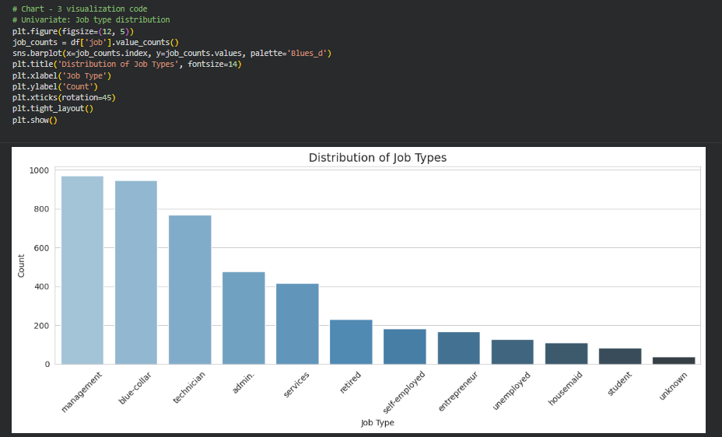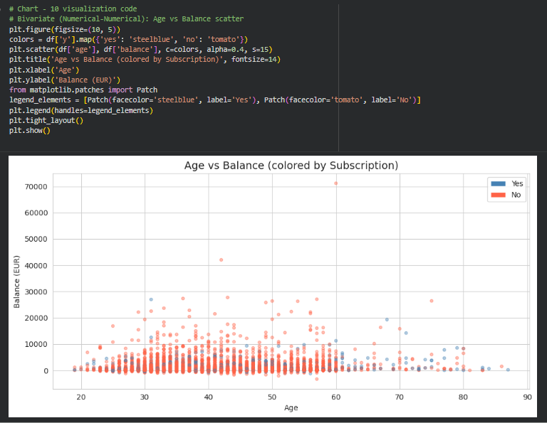

These analyses help identify major customer segments served by the bank.

Subscription Trend Analysis
One of the primary objectives is to understand customer subscription behavior.
The following analyses are performed:
- Customers who subscribed
- Customers who did not subscribe
- Subscription rate across occupations
- Subscription rate across education levels
- Subscription rate based on previous campaign outcome
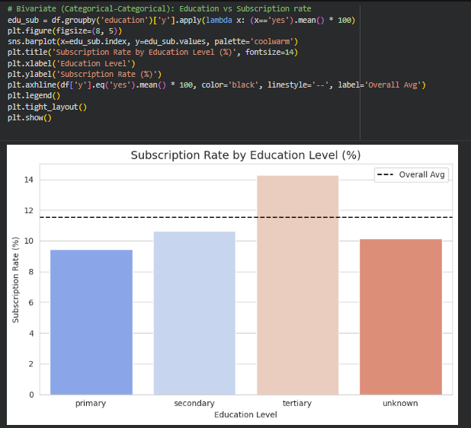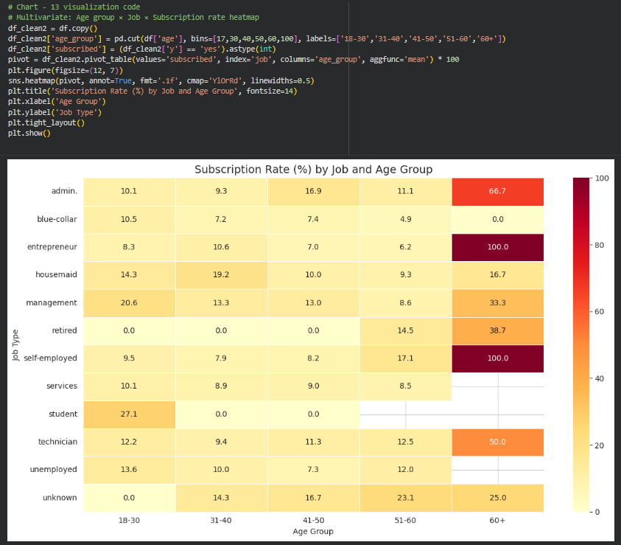
These insights help understand which customer groups respond positively to marketing campaigns.

Campaign Performance Analysis
Marketing campaign features are analyzed to evaluate campaign effectiveness.
Important variables include:
- Campaign contacts
- Previous contacts
- Previous campaign outcome
- Contact duration
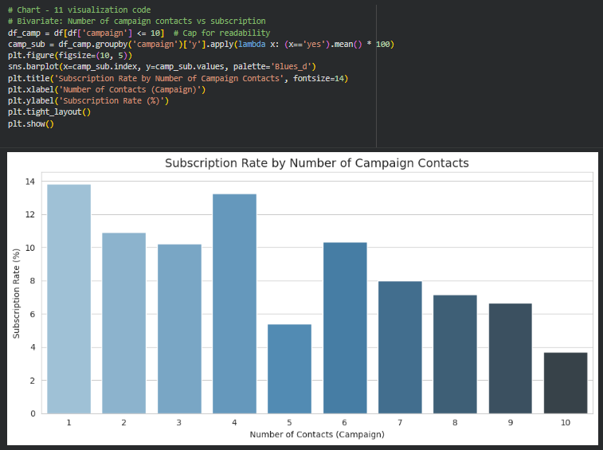
The analysis reveals factors that significantly influence customer conversion.

Outlier Detection
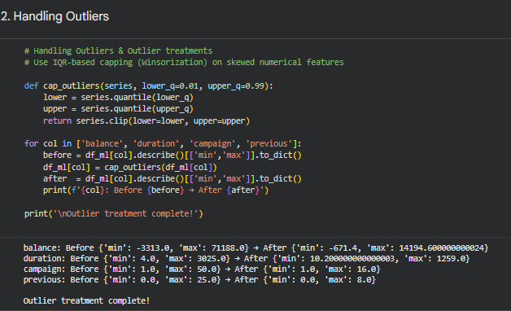
Outliers are identified using the Interquartile Range (IQR) method implemented with Spark's distributed functions.
Approximate quantiles are calculated using Spark's approxQuantile() method, which efficiently estimates quartiles without scanning the entire dataset repeatedly.
Detecting outliers helps improve model quality and reduces the influence of extreme observations.

Spark Aggregation Operations
Apache Spark performs several distributed aggregation operations, including:
- groupBy()
- count()
- avg()
- max()
- min()
- orderBy()
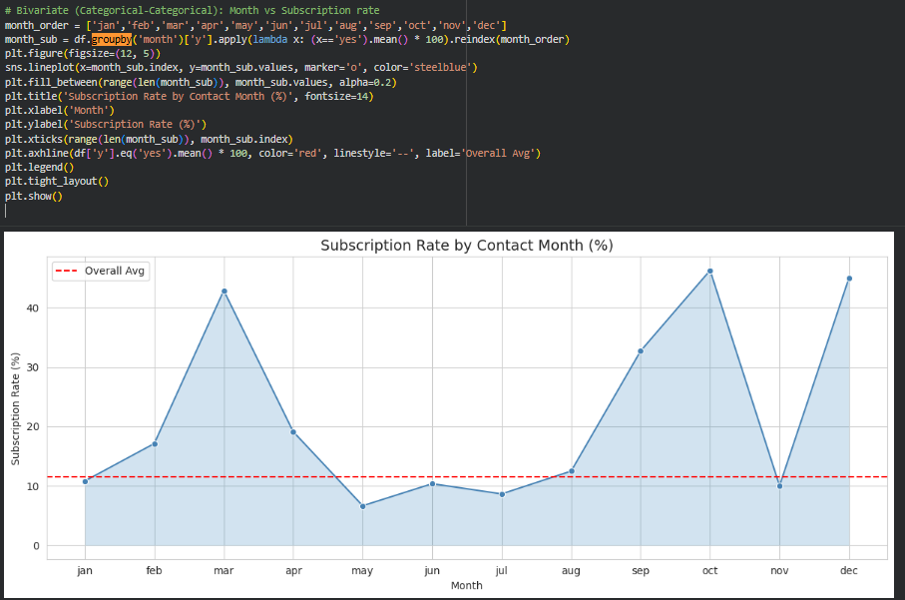
These operations execute in parallel across Spark partitions, significantly improving processing speed compared to traditional single-machine analysis.

Key Insights Obtained
The exploratory analysis revealed several important business insights:
- Customers with successful previous campaign outcomes have a higher probability of subscribing.
- Contact duration is one of the strongest indicators of subscription.
- Customers in student and retired categories exhibit higher subscription rates than several other occupational groups.
- Housing loan status influences customer responses.
- Certain months show better campaign performance than others.
- The dataset is highly imbalanced, with a much larger proportion of customers not subscribing to term deposits.
These insights provide valuable guidance for building predictive machine learning models.

Advantages of Spark-Based EDA
Using Apache Spark offers several advantages over traditional data analysis approaches:
- Parallel execution across multiple partitions
- Faster processing of large datasets
- Reduced memory bottlenecks
- Scalable computation
- Integration with Spark SQL and Spark ML
- Efficient distributed aggregations
- Seamless transition from data exploration to machine learning

Challenges Faced
Several challenges were encountered during the exploratory analysis:
- Understanding distributed execution instead of sequential processing.
- Avoiding excessive conversion of Spark DataFrames into Pandas DataFrames.
- Efficiently computing summary statistics on distributed partitions.
- Managing partition sizes for balanced workload distribution.
- Detecting outliers efficiently using approximate quantile calculations.

Learning Outcomes
Through this phase, the following concepts were learned:
- Working with distributed Spark DataFrames.
- Performing scalable exploratory data analysis.
- Using Spark SQL functions for aggregation.
- Detecting missing values and outliers efficiently.
- Understanding customer behavior through distributed analytics.
- Preparing clean and meaningful data for machine learning.

Conclusion
The Exploratory Data Analysis phase successfully demonstrated how Apache Spark can efficiently process and analyze large-scale banking datasets using distributed computing techniques. The insights obtained during this stage provide the foundation for feature engineering and predictive modeling in the subsequent Spark ML phase. By leveraging distributed execution, Spark significantly improves the scalability and efficiency of exploratory analysis compared to traditional data processing methods.

